**Equation for the modified GNN and GMN:**

**1.Modified GNN:**

Standard GNN equation:

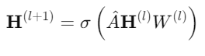

Modified GNN equation:



**2.Modified GMN:  
 